参考：https://commons.apache.org/

# HttpClient

* **Apache HttpClient 3** ：

已不维护， Commons HttpClient，所属包 org.apache.commons.httpclient，

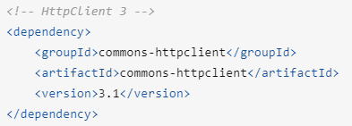

* **HttpClient 4**

Apache HttpComponents 下的项目，所属包 org.apache.http，maven 依赖如下

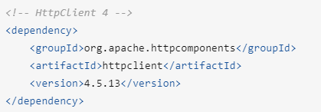

CloseableHttpClient HTTP_CLIENT = HttpClients.createDefault();

HttpGet/HttpPost/

# FileUpload